Stop Hate UK T-shirt Design Competition!

Thank you for expressing an interest in the Stop Hate UK T-shirt Design competition. We are on the lookout for winning designs that we can print and sell with the aim of raising vital funds for those experiencing hate and discrimination across the UK.
Stop Hate UK exists to keep our communities safe.
Everyday up and down the country, we witness the incredible strength and bravery it takes to report a Hate crime. We listen. We believe. We act - we do whatever it takes to meet the needs of our callers to make sure they feel seen and are heard when reporting. Our work in education remains a key function in enhancing support systems – working across the corporate, statutory and community sector to make sustainable changes.
Your creativity and design skills could help us to keep the momentum going against anti-discrimination. The money we raise will mean more people will be able to get vital helpline support, access to educational materials, and know what to do if they experience or witness it happening.
Your design could change minds and hearts- every penny raised will go directly to sustaining Stop Hate UK's services so that communities, families, and individuals don't suffer in silence when they experience a Hate Crime.
Please make a submission via email. You can use the space below to show a preview of your design.
We will ask that you be available on the 6th May 2022 in London to join us for the announcement of the winner. Venue to be announced in May.
Name
Address
Contact number
Email
Tell us about yourself (100 words max)

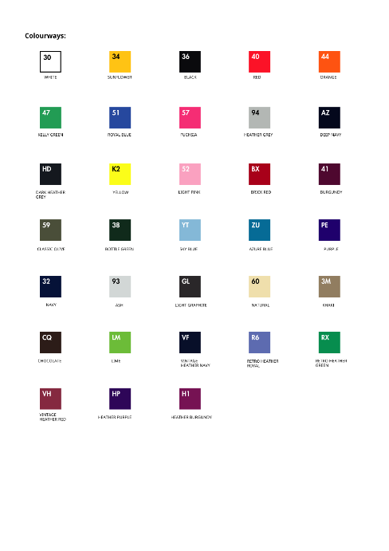
We want you have the best chance of winning, so here are a few guidelines to follow. Please use the box below in the next section to showcase a preview of your design. You should attach your design as a .psd or vector file in an email.
- Designs should be on the front of the t-shirt and can be from any base from the colours to the right. There is no limit to the number of colours that can be used.
- The font size and slogan can be any font, size and position that you like.
- Preferred file types: Layered Photoshop (PSD) or Vector (AI, SVG, EPS) with a limit of 5mb.

Use this box below if you would like to showcase the design or a preview here.

